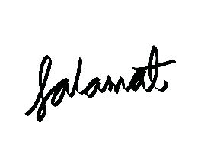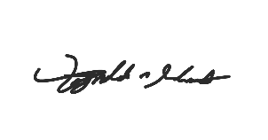

REYNALDO A. SALAMAT JR.

REYNALDO C. SALAMAT

REYNALDO A. SALAMAT JR.

REYNALDO C. SALAMAT

10-04-2021

10-04-2021

10-04-2021

10-04-2021

**Declaration**

I have read and understood the above syllabus in full and in participating in this course I agree to the above rules. I have a clear understanding of the policies and my responsibilities, and I have discussed everything unclear to me with the instructor.

I will adhere to the academic integrity and policy and I will treat my fellow students and my teacher with due respect.

I understand that this syllabus can be modified or overruled by announcements of the instructor in class or on any social media site at any time.

______________________________________ ____________________ _______________

Student’s Printed name Signature Date

______________________________________ ____________________ _______________

Parent’s Printed name Signature Date

***Student’s Copy***

-------------------------------------------------------------Cut here---------------------------------------------------------------

**Declaration**

I have read and understood the above syllabus in full and in participating in this course I agree to the above rules. I have a clear understanding of the policies and my responsibilities, and I have discussed everything unclear to me with the instructor.

I will adhere to the academic integrity and policy and I will treat my fellow students and my teacher with due respect.

I understand that this syllabus can be modified or overruled by announcements of the instructor in class or on any social media site at any time.

______________________________________ ____________________ _______________

Student’s Printed name Signature Date

______________________________________ ____________________ _______________

Parent’s Printed name Signature Date

***Instructor's Copy***